190905513 LAB 05 MOHAMMAD DANISH EQBAL

BATCH A3 RECURSIVE DESCENT PARSER SECTION A

LAB EXERCISES:

Write a recursive descent parser for the following simple grammars.

1. S-> a | > | ( T )
T-> T , S | S

Program:

#include<stdio.h>
#include<stdlib.h>
#include<string.h>

int curr=0;
char str[100];

void S();
void T();
void Tprime();

void reject()
{
printf("ERROR..\n");
exit(0);
}

void valid()
{
printf("SUCCESS..\n");
exit(0);
}

void S()
{
if(str[curr]=='a')
{
curr++;
return;
}
else if(str[curr]=='>')
{
curr++;
return;
}
else if(str[curr]=='(')
{
curr++;
T();
if(str[curr]==')')
{
curr++;
return;
}
else
reject();
}
else
reject();
}
void T()
{
S();
Tprime();
}

void Tprime()
{
if(str[curr]==',')
{
curr++;
S();
return;
}
}

int main()
{
printf("Enter string: ");
scanf("%s",str);
S();
if(str[curr]=='$')
{
valid();
}
else
reject();
}

Output:
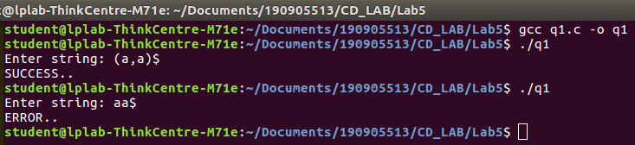

2. S-> UVW
U-> (S) | aSb | d
V-> aV | ε
W-> cW | ε

Follow(V) = {'c',')','b','$'}
Follow(W) = {')','b','$'}

Program:

#include <stdio.h>
#include <stdlib.h>
#include <string.h>
int curr = 0;
char str[100];

void S();
void U();
void V();
void W();

void invalid(){
printf("ERROR..\n");
exit(0);
}
void valid(){
printf("SUCCESS..\n");
exit(0);
}

void S(){
U();
V();
W();
}

void U(){
if(str[curr]=='('){
curr++;
S();
if(str[curr]==')'){
curr++;
}
else{
invalid();
}

}
else if(str[curr]=='a'){
curr++;
S();
if(str[curr]=='b'){
curr++;
}
else{
invalid();
}

}
else if(str[curr]=='d'){
curr++;
}
else{
invalid();
}
}

void V(){
if(str[curr]=='a'){
curr++;
V();

}
else if(str[curr]=='c'||str[curr]==')'||str[curr]=='b'||str[curr]=='$'){
return;
}
else{
invalid();
}
}

void W(){
if(str[curr]=='c'){
curr++;
W();

}
else if(str[curr]==')'||str[curr]=='b'||str[curr]=='$'){
return;
}
else{
invalid();
}
}

int main(){
printf("Enter String: ");
scanf("%s", str);
S();
if(str[curr] == '$')
valid();
else
invalid();
}

Output:
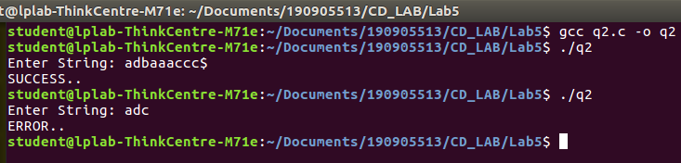

3. S-> aAcBe
A-> Ab|b
B-> d

After removing left recursion the new grammer is:
S -> aAcBe
A -> bAprime
Aprime -> bAprime|e
B -> d

Follow(Aprime) = {'c'}

Program:

#include <stdio.h>
#include <stdlib.h>
#include <string.h>
int curr = 0;
char str[100];

void S();
void A();
void Aprime();
void B();

void invalid(){
printf("ERROR..\n");
exit(0);
}
void valid(){
printf("SUCCESS..\n");
exit(0);
}

void S(){
if(str[curr]=='a'){
curr++;
A();
if(str[curr]=='c'){
curr++;
B();
if(str[curr]=='e'){
curr++;
}
else{
invalid();
}
}
else{
invalid();
}
}
else{
invalid();
}
}

void A(){
if(str[curr]=='b'){
curr++;
Aprime();

}
else{
invalid();
}
}

void Aprime(){
if(str[curr]=='b'){
curr++;
Aprime();

}
else if(str[curr]=='c'){
return;
}
else{
invalid();
}
}

void B(){
if(str[curr]=='d'){
curr++;

}
else{
invalid();
}
}

int main(){
printf("Enter String: ");
scanf("%s", str);
S();
if(str[curr] == '$')
valid();
else
invalid();
}

Output:
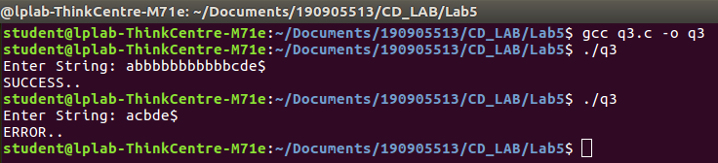

4. S-> (L) | a (s,s,s,s,s)
L-> L,S | S

After removing left recursion the new grammer is:
S -> (L)|a
L -> SLprime
Lprime -> ,SLprime|e

Follow(Lprime) = {')'}

Program:

#include <stdio.h>
#include <stdlib.h>
#include <string.h>
int curr = 0;
char str[100];

void S();
void L();
void Lprime();

void invalid(){
printf("ERROR..\n");
exit(0);
}
void valid(){
printf("SUCCESS..\n");
exit(0);
}

void S(){
if(str[curr]=='('){
curr++;
L();
if(str[curr]==')'){
curr++;
}
else{
invalid();
}
}
else if(str[curr]=='a'){
curr++;
}
else{
invalid();
}
}

void L(){
S();
Lprime();
}

void Lprime(){
if(str[curr]==','){
curr++;
S();
Lprime();

}
else if(str[curr]==')'){
return;
}
else{
invalid();
}
}

int main(){
printf("Enter String: ");
scanf("%s", str);
S();
if(str[curr] == '$')
valid();
else
invalid();
}

Output:
